BEST WESTERN Hotel Santaka
J. Gruodžio g. 21, LT-44293 Kaunas, Lithuania
Tel.: (+370 37) 302702, 302721
Fax. (+ 370 37) 302700, 302722
E-mail: office@santakahotel.eu

HOTEL RESERVATION FORM
For the participants of the international conference “BALTTRIB 2013”
(14 - 15 November, 2013)

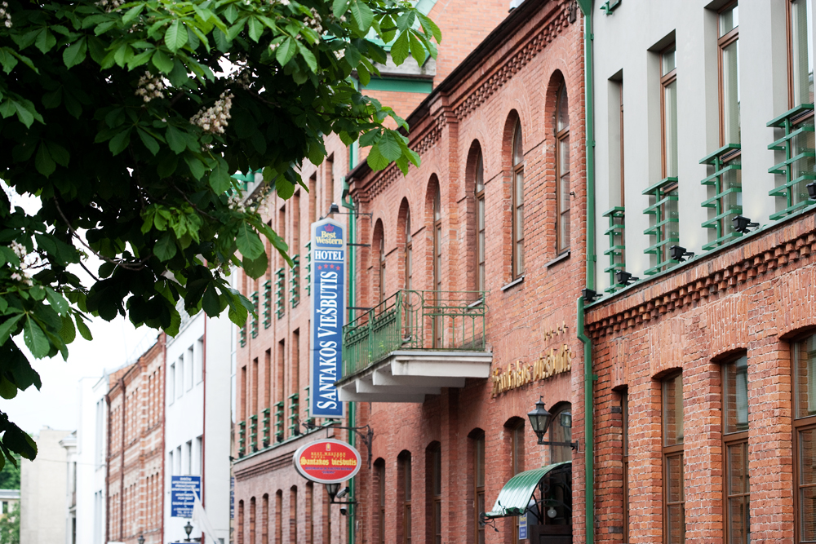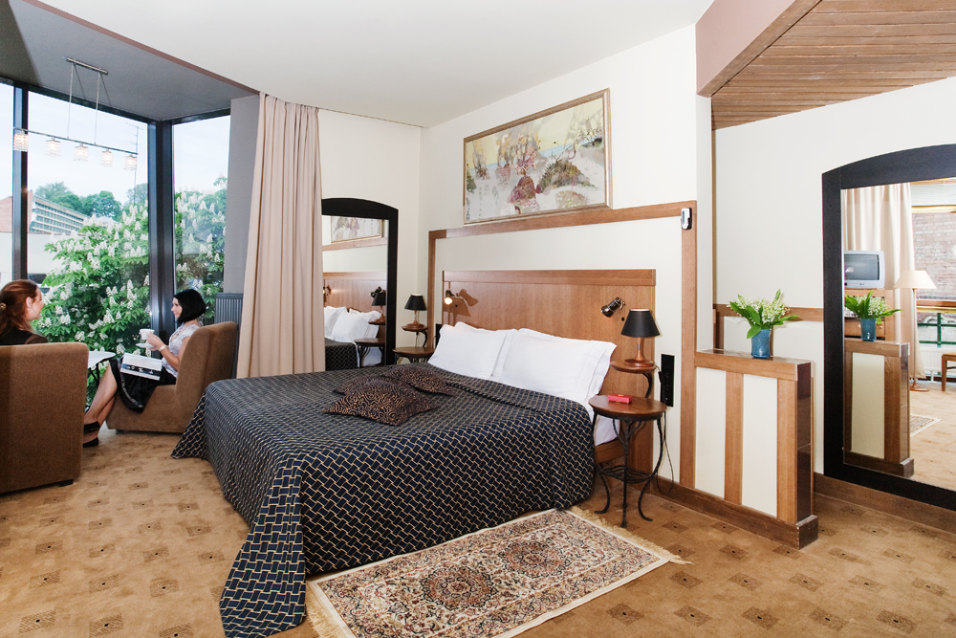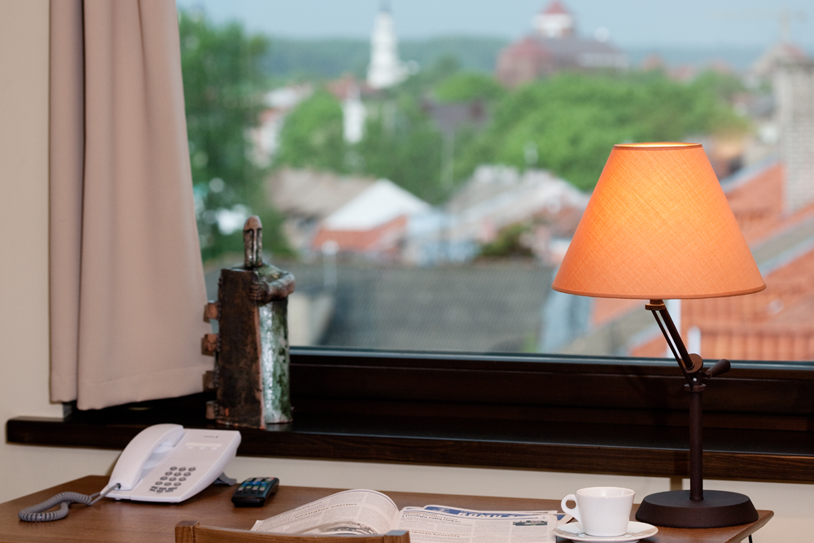

LAST NAME:
FIRST NAME:
ADDRESS:
PHONE :
E-MAIL:
ARRIVAL DATE:
DEPARTURE DATE:

ROOM TYPE | PRICE | PLEASE CHOOSE ROOM TYPE | PLEASE SPECIFY NO. OF ROOMS
STANDARD SINGLE | 45 EUR
STANDARD DOUBLE OR TWIN | 50 EUR
SPECIAL NOTES:

- Room rate includes full breakfast, sauna and swimming pool (from 7:00 till 10:00), car parking place and VAT.
- The official exchange rate is 1 EUR = 3,4528 LTL. Check-in starts from 14:00; check-out until 12:00.
- Guaranteed reservation can be cancelled without any charge 24 hours before arrival date.
WE KINDLY ASK YOU TO SEND US YOUR CREDIT CARD INFO TO GUARANTEE THE RESERVATION:
VISA American Express Eurocard/Mastercard Other
Number: Expiry date:
PLEASE MARK IF YOU NEED TRANSFER SERVICE: Yes No
Vilnius airport – Hotel (270 LTL) Kaunas airport – Hotel (60 LTL)
Please provide flight details: Arrival time Flight number

PLEASE SEND US THIS FORM BY FAX +370 37 302700; +370 37 302722 OR ANY OF THESE E-MAILS office@santakahotel.eu; incoming@santakahotel.eu

NB!
- If You do not guarantee Your reservation by Your credit card and do not arrive at the hotel until 6.00 p.m., the reservation may be cancelled. If the Hotel has Your guarantee – the room will be held for You until 12.00 a.m. of the next day.
- In case of NO SHOW without any warning, the Hotel charges 100% of room rate per night.
- Please note, that this form does not guarantee a reservation. Reservations will be confirmed upon availability.

CHOOSE THE BEST!

